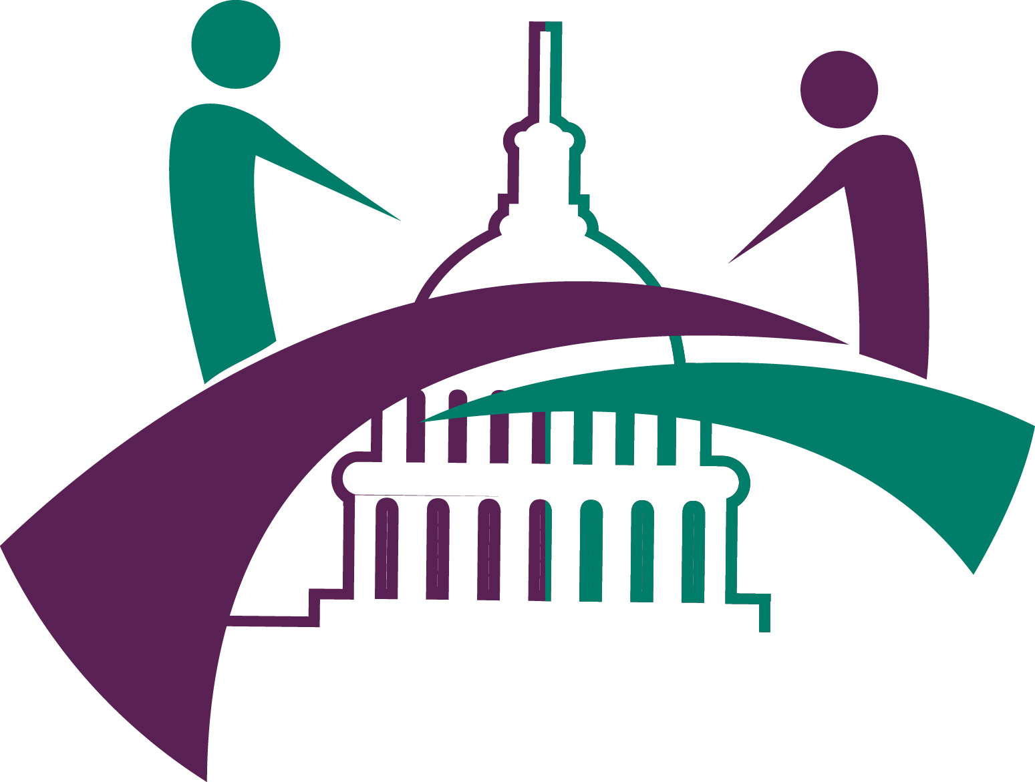
2023 SNP Alliance Members-only Policy Roundtable

“Driving the Future of Special Needs Managed Care”
April 17-18, 2023
Yours-Truly Hotel, Washington, DC

–PRELIMINARY AGENDA –
Monday, April 17
8:00am – 5:00pm |  | Registration
7:45am – 8:45am |  | Breakfast
8:45am – 9:30am |  | Membership Meeting  Welcome and Introduction of SNP Alliance Board and Members  Welcome to the New Board Members  Thank you to Sponsors  Words from Outgoing CEO – Cheryl Phillips, M.D.  Facilitators:  Eve Gelb, SNP Alliance Board Chair, SCAN Health Plan  Cheryl Phillips, MD, AGSF, Outgoing President and CEO, SNP Alliance
9:30am –10:15am |  | Congressional Update  Discussants:  Ginger Loper, Loper Consulting  Elizabeth Barnett, Avenue Solutions  Facilitator:  Will Dede, Assoc Director health Policy, SNP Alliance
10:15am – 10:45am  10:45am – 11:00am | Session: Performance Evaluation from the SNP Perspective:  The Current Landscape  From a high-level perspective, we will outline key performance evaluation focus areas and chart next stage efforts for SNPs, making the connections for government program policy leads to inform priorities and action. In doing so, we will focus on two recent themes in performance evaluation – social needs and equity.  Discussants:  Sarah Rosenblum, Senior Analyst, ATI Advisory  Deborah Paone, DrPH, Performance Evaluation Lead and Policy Consultant, SNP Alliance  BREAK
11:00am –11:40pm  11:40 am – 12:00pm | Session: Examining SNP Performance: Quality, Cost, Equity  Drawing from his research and other evidence, Dr. Roberts will explore four key areas examining SNP performance: (1) quality, cost, and equity of D-SNPs, (2) comparing FIDE-SNPS to coordination-only D-SNPs, (3) integrated managed care models for dually-eligible beneficiaries, (4) filling key research gaps to inform policy and practice  Presenter:  Eric Roberts, PhD, Assistant Professor, University of Pittsburgh, School of Public Health (PA)  Reaction Panel to Dr. Roberts  Thomas Von Sternberg, MD Medical Director Medicare, MHSO, Care Management and Government Programs, HealthPartners (MN)  Deborah Paone, DrPH, Performance Evaluation Lead and Policy Consultant, SNP Alliance (DC)
12:00pm – 12:45pm | Networking Lunch
12:45pm – 1:30pm  1:30pm – 1:40pm | Concurrent Peer Roundtable Discussions (50 min)  DISCUSSION A: Feasibility and Promise of Improving Complexity Case Mix, and Predictive Models for Special Needs Populations – Current case mix and grouper indexes do not include characteristics important in special needs populations, such as functional status, frailty, social risk/social needs, and condition complexity (medical, behavioral). What are the possibilities and feasibility to improve case mix and predictive models to capture characteristics prevalent in special needs populations? What would it take to move this forward? Tom and Deborah will share the work of the Beneficiary Complexity Workgroup through the SNP Alliance. Dr. Roberts will respond, and we will engage with all present—to explore the potential value-add of such an index. This is an interactive, exploratory discussion.  Discussants:  Thomas Von Sternberg, MD Medical Director Medicare, MHSO, Care Management and Government Programs, HealthPartners (MN)  Deborah Paone, DrPH, Performance Evaluation Lead and Policy Consultant, SNP Alliance (DC)  Reactor:  Eric Roberts, PhD, Assistant Professor, University of Pittsburgh, School of Public Health (PA)  DISCUSSION B: Communications Accessibility: Addressing Language and Digital Health Literacy with Tools and Tips (Workgroup format)  Resources for Integrated Care (RIC)  Break (return to general session)
1:40pm– 2:30pm | Session: Perspectives on Meaningful Measurement: Moving Forward  Putting on the lenses of persons with lived experiences, we examine MA quality measurement, using the HOS measure(s) as our focus. We discuss what meaningful measurement is, areas for change, and how measurement should avoid concretizing stereotypes to promote better usefulness of measure results and promote health equity goals. We discuss ideas and options for moving forward and engage other stakeholders toward more meaningful measurement for special population groups.  Presenters:  Rebecca Kirch, JD, Executive VP Policy and Programs, National Patient Advocate Foundation (DC)  Burt Pusch, PhD, Member Centricity Innovation and Strategy Consultant, Commonwealth Care Alliance (MA)  Deborah Paone, DrPH, Performance Evaluation Lead and Policy Consultant, SNP Alliance (DC)
2:30pm – 3:15pm | Session: Emerging trends in SNP CMS Audits  This session will explore trends in special needs plan audits, including changes in the focus of the CMS auditors over the last 2 years.  Presenter:  - Ashley Cabrera, CHC, Senior Vice President Product, Strategy and Chief Compliance Officer, MHK
3:15pm – 3:30pm | Break
3:30pm – 4:15pm | Session: What you Told Us: Highlights from the 2022 SNP Alliance Member Annual Survey  Through participation of the SNP Alliance health plans in this annual survey, we are able to present the unique characteristics of different SNP types, their enrollment, health care use, and priority issues in performance measurement and addressing social needs of their members. This is the 8th year of the survey.  Presenter:  Deborah Paone, DrPH, Performance Evaluation Lead and Policy Consultant, SNP Alliance
4:15pm – 4:45pm  4:45pm – 5:05pm | Session: Bringing Modernized Kidney Care to the Home  More than 37 million Americans are living with chronic kidney disease but up to 50% of them don’t know it. Monogram Health was founded in 2019 to address the desperate need for a patient-centered approach to slow progression of the disease and transform modern American kidney care through an innovative home-based model. Today, the Nashville-based company is the leading value-based specialty provider of in-home, evidence-based care and benefits management for patients across 34 states who live with polychronic conditions including chronic kidney and end-stage renal disease and their related metabolic disorders. This session will explore some of the operational strategies needed to provide in-home kidney care services and address the added benefits to both the patient and the health plan.  Presenter:  Dr Amal Agarwal, Chief Clinical Officer, Monogram Health  Hold for Nourished RX (20 min)
5:45pm – 7:00pm | Reception:  Sponsored by:  Intus (Gold)  NourishedRX (Gold)  Toney HealthCare (Silver)  MHK (Silver)  Patient Patterns (Silver)  HealthEdge/Datalink (Silver)  Pyx Health (Silver)
Tuesday, April 18
7:30am – 8:30am  8:00 am – 8:20am | Breakfast  Sponsored Session: Using Automated Data-driven Workflows to Improve Clinical Outcomes and Population Health Management  Intus Care
8:30am – 9:10am | Session: HMA Tool Kit: Workforce shortages and access for rural dual eligibles  - Susan McGeehan, HMA
9:10am –9:50am  9:50am - 10:30am  10:30am – 10:45am  10:45am – 11:40am | Session: State Perspectives: Leveraging Crosswalk Exceptions to Promote Integration of Medicare and Medicaid Benefits in  D-SNPs  In this session, Danielle Chelminsky from the Inegrated Care Resource Center (ICRC) will provide a brief overview of current and planned state activities to leverage D-SNPs to integrate Medicare and Medicaid benefits for dually eligible individuals, followed by a summary of key topics and considerations for states planning to use D-SNP contracts for this purpose. Danielle will then explain how D-SNPs can use crosswalk exceptions (described at 42 CFR 422.530(c)) to move dually eligible D-SNP enrollees from one plan bebefit package (PBP) to another in order to facilitate D-SNPs' ability to offer integrated Medicare and Medicaid benefits to their members.  Presenter  - Danielle Chelminsky, MPH Researcher Mathematica, Integrated Care Resource Center  Session: The D-SNP Integration Advocacy Agenda: Coming to Consensus-Next Steps in Preserving Key Elements for Integration Proposals  Allison Rizer will lead an interactive discussion with SNP Alliance members on current integration proposals, with the goal to identify key elements that should be addressed and priorities for what is still needed moving Medicare-Medicaid integration efforts forward.  Presenter  - Allison Rizer, MHS, MBA, Principle and Head of Medicare-Medicaid Integration and LTSS Innovation Practice, ATI Advisory  Break  Session: MMCO Panel and Discussion  The Medicare-Medicaid Coordination Office (MMCO) returns to the SNP Alliance Spring Roundtable for a discussion on issues and policies impacting D-SNPs and MMPs. MMCO will provide initial updates on the present landscape of integration and their priorities for the upcoming year, followed by conversation and questions facilitated by Pam Parker, SNP Alliance Integration Consultant. Finally, SNP Alliance members will have the chance to pose additional questions to MMCO.  Presenters:  Marla Rothouse, Senior Technical Advisor, Medicare-Medicaid Coordination Office  Lindsay Barnette, Director, Models, Demonstrations and Analysis Group, Medicare-Medicaid Coordination Office  Nicole Perry, Special Assistant, Medicare-Medicaid Coordination Office  Moderator:  Pamela Parker, Health Policy Consultant – Dual Integration, SNP Alliance
11:40am – 12:30pm | Session: Advance Notice – Impact on Special Needs Plans  Much has been discussed about the recent CMS Advance Payment Notice for PY 2024. At the time of this meeting, it will either have been finalized as proposed, or modified. Nick will provide an overview of the impact -both in what was proposed, as well as exploring some of the specific issues related to coding risk adjustment. He will also provide a summary of the analysis of the SNP Alliance member plan data (based on the information submitted)  Presenter:  - Nicholas Johnson, FSA, MAAA, Principal & Consulting Actuary, Milliman
12:30pm – 12:40pm | Closing Session: “Wrap-Up, Next Steps & Adjournment”  A quick review of meeting highlights and SNP Alliance priorities for 2023. Plus, a final thank-you to speakers, sponsors and attendees.  - Incoming President and CEO, SNP Alliance

